Highlights:

- 2019 and 2020 now tested via Hamilton County Lake Monitoring Program (previously Paul Smith’s / ALAP)
- Pandemic drove record visitors to ADKs, some indicators of increased human activity (nitrate, conductance, etc)
- No aquatic invasives known (1/2 of Hamilton County lakes have AIS)
- pH and Alkalinity now indicate the lake has adequate acid neutralization capability
- No other major change in status from previous years
  - Lake Abanakee is a typical Adirondack lake – measurements are within the norms for most lakes
  - Mesotrophic state – based on Phosphorus, Chlorophyll-A, and visibility
  - Chlorophyll-a and conductance declining
  - Sodium and Chlorine above background levels – low impact due to road salt

Hamilton County Soil and Water District (HCSWD) lake monitoring
HCSWD also does lake testing for Hamilton County lakes. This was done from 1998 to 2003. They were restarted in 2013 and continue to monitor Lake Abanakee for mostly the same things as ALAP (ALAP does Conductivity and Color, HCSWD does Aluminum and Nitrates). It appears the measurements are similar (compared 2017 tests, there are no published 2018 results yet). We can always compare our measurements with other lakes in ALAP via their annual reports. Water monitoring data is available on-line at http://www.hamiltoncountyswcd.com/images/files/lakemonitoring/The_State_of_Hamilton_County_Lakes_a_25yr_Perspective_2comressed.pdf
2020 Lake Abanakee report - https://storymaps.arcgis.com/stories/2e050cd746de44b2a0ec7862d09901f1
2019 Lake Abanakee report - http://www.hamiltoncountyswcd.com/images/files/lakemonitoring/Water_Monitoring_Report__2019.pdf

What can we do??? Keep up the good work!
- Make sure septic systems aren’t failing
- Limit lawn fertilizing to reduce Phosphorous and other nutrients
- Be judicious in using salt, it’s having an impact on most lakes
- Keep using phosphate free laundry products

Summary of Lake Abanakee from 2020
Lake Abanakee is a 208 ha lake located in Hamilton County in the Town of Indian Lake. The lake is located within a 49,953 ha watershed dominated by forests.
- The Secchi disk transparency of the lake averaged 2.9 meters in 2020. The transparency of the lake has remained relatively constant over the 15 years of monitoring (and likely limited by depth of lake), with no statistical trend detected in the data. ALAP range is .9-7.7
- Chlorophyll-a concentration, a surrogate for algal productivity averaged 3.0 μg/L in 2020. Over the 15 years of monitoring average chlorophyll concentrations have ranged from 1.2 to 6.2 μg/L with a significant downward trend detected in the data at a rate of approximately 0.3 μg/L/year. ALAP range is .5 – 12.2
- Total phosphorus concentration averaged 6.9 μg/L in 2020 (vs 10.4 in ‘17). Concentrations of this nutrient have been highly variable over time, and ranged from < 5 μg/L to 18.3 μg/L. (but, consistently lower since NYS phosphate ban in detergent), No statistical positive or negative trend was detected in the data. ALAP measurements are from 4 to 42
- Lake Abanakee is a circumneutral water body with a typical pH value average of 7.0 (ALAP range is 5.8-9.2) pH units. The acid neutralizing ability of the lake is now adequate (alkalinity 6.1 mg/L – which better than ‘17 at 9.3) and the lake remains sensitive to acid deposition.
- Adirondack lakes in watersheds without paved roads typically have sodium and chloride concentrations less than 0.55 and 0.24 mg/L, respectively. The 2020 sodium and chloride concentrations in Abanakee Lake averaged 3.2 mg/L for sodium and 4.3 mg/L for chloride. These elevated (and increasing) values suggest the chemistry of the lake is influenced by the 43 km of salted state roads in the watershed. . The concentrations of these chemicals are well below the EPA drinking water standard established for sodium (20 mg/L) and the guideline recommended for chloride (250 mg/L). ALAP ranges are .5-50 for 75% of the lakes
- Calcium concentrations in the lake (2.8 mg/L) are below the threshold required for the establishment of a viable zebra mussel population (12-20 mg/L). ALAP range is 2-5 for 75% of the lakes

HCSWD report – 2020 Lake Abanakee Overview
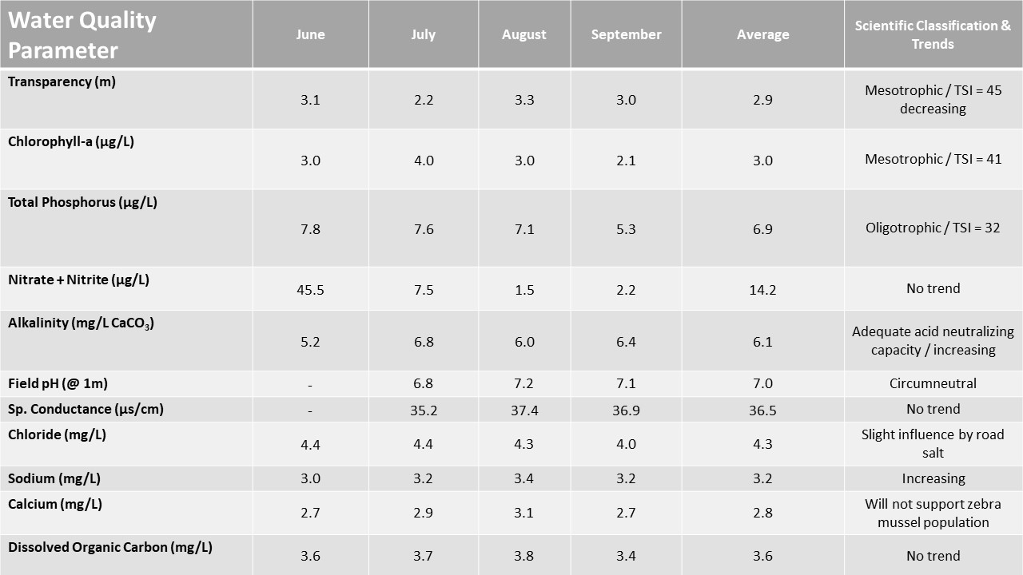
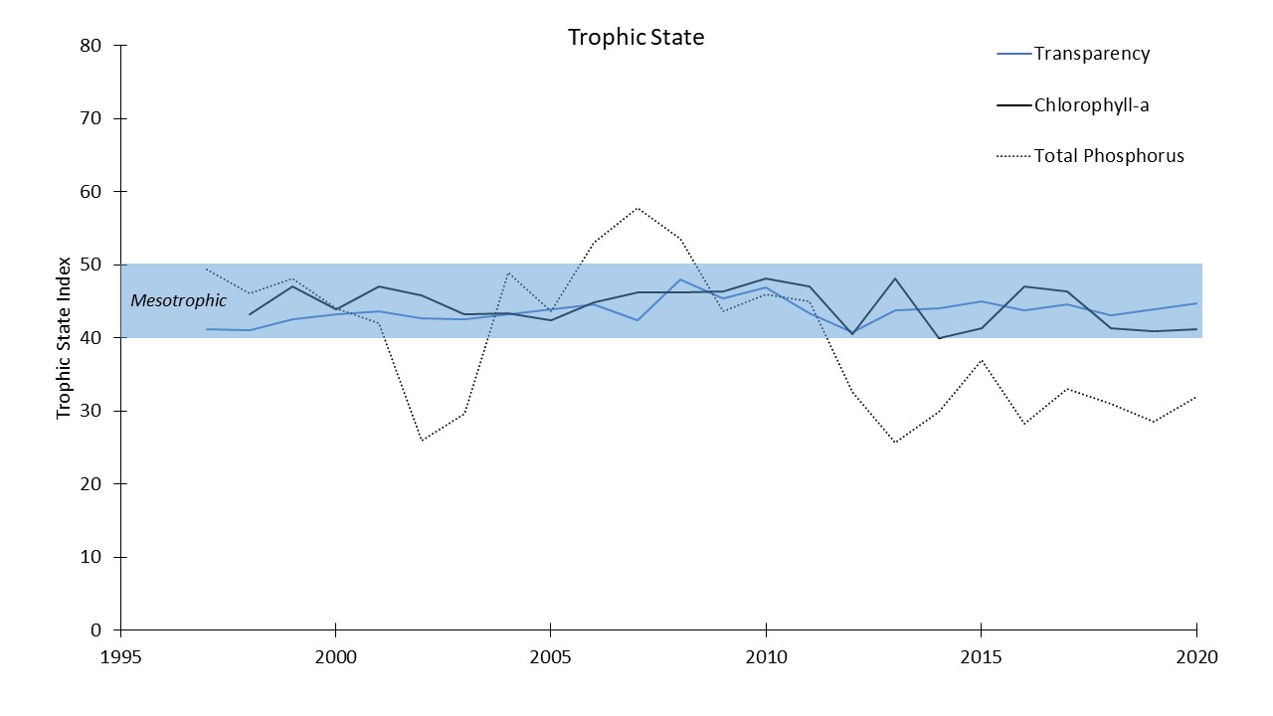
A time series showing changes in Lake Abanakee's trophic classification using Carlson's Trophic State Index (TSI).
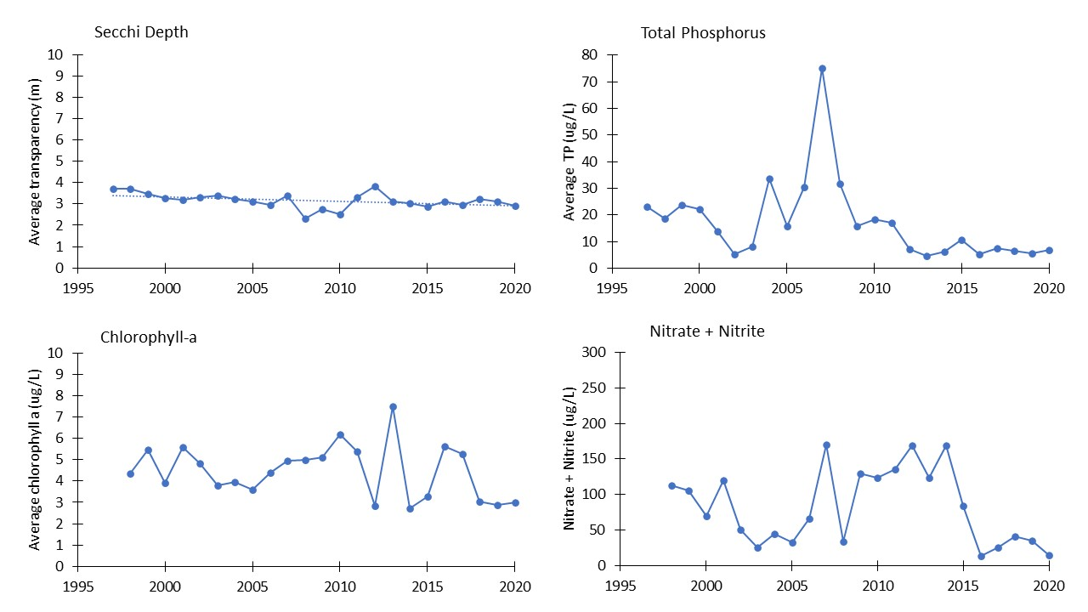
The above figure shows average values of trophic state indicators of Lake Abanakee between the years 1993 and 2020. Like many of our study lake, the transparency of Lake Abanakee exhibits a slight but significant downward trend (p = 0.04).
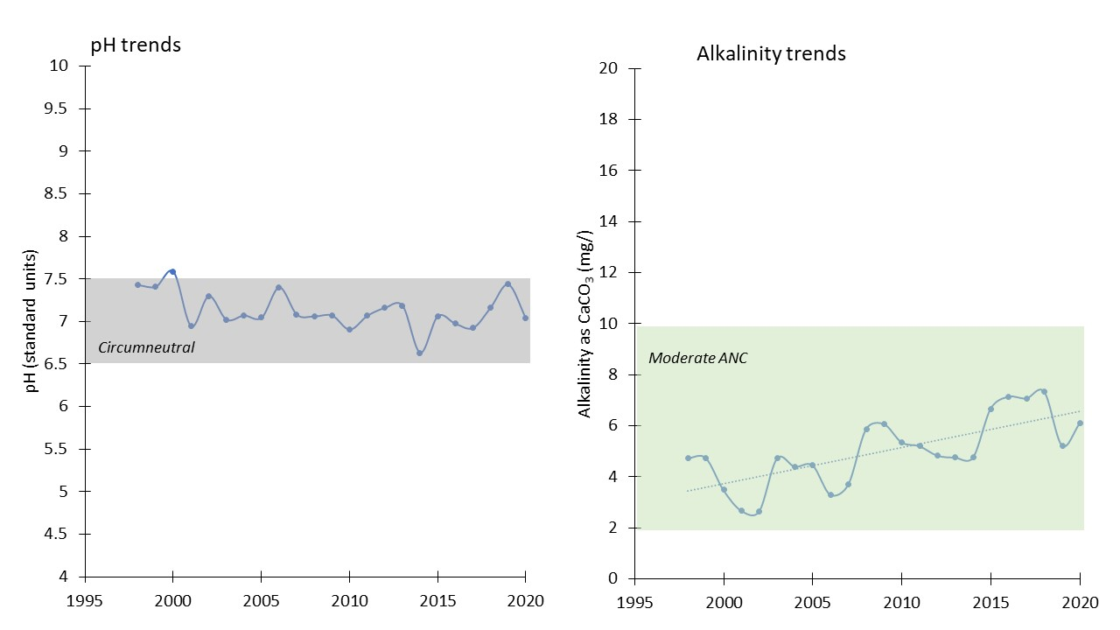
The above figures show changes in pH and Alkalinity between the years 1993 and 2020. The lake remains circumneutral, with an average pH of 7.0 during the 2020 sampling season. Alkalinity continues to exhibit and increasing trend (p= 0.0001), indicating recovery from the effects of acid deposition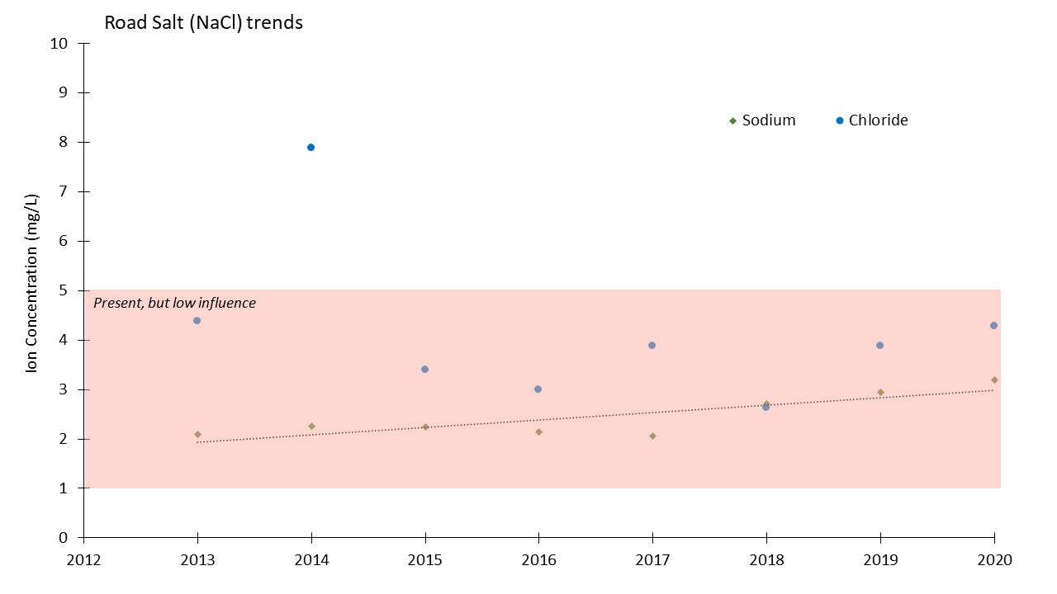
The above figure shows average concentrations of Sodium and Chloride between the years 2013 and 2020. Elevated concentrations of Sodium and Chloride indicate that the water chemistry of the lake is being influenced by road salt application. Sodium concentrations exhibit an increasing trend (p= 0.009).

